Central Ohio Technical College
Program Review Process
Revised: August 2023

Autumn Semester

- By the end of week 2, programs under review for the academic year will be contacted by email with a notification that data collection has begun. Share with program designees:

  - A copy of this document (Program Review Process),
  - A blank copy of the program review template,
  - Anticipated dates including the deadline, Student Learning Assessment Steering Committee (SLASC) program review roundtable and Institutional Research & Effectiveness (IR&E) program review office hours (which all will occur in spring semester),
  - Any previously completed reviews for their academic area,
  - Expectation of participation in a thoughtful and objective review.

- By the end of autumn semester, programs under review will receive an updated program review data template that has been populated with data sourced by IR&E.

  - Programs may begin (but are not required) to draft responses on their copy of the template prior to receiving this updated version.
    - If there are multiple working drafts, they will be merged with the data-populated version once available.
  - Programs may (but are not required to) source their own data to assist with drafting responses.
    - Other sources may include Student Learning Assessment Outcomes, Technical Advisory Committee Meeting Minutes, results of surveys administered by the program, alumni information, and programmatic accreditation information.

Spring Semester

- At the start of spring semester, IR&E will send calendar invites for important dates including:

  - IR&E program review office hours,
    - These are optional meetings for programs to ask questions, share draft responses, and seek additional sources of data,
  - The deadline for turning in completed reviews (typically around April 1st each year), and
  - The SLASC program review roundtable (typically around April 15th each year)
    - The roundtable is held on the last SLASC meeting of spring semester.

- Programs complete the review. This includes:

  - Responding to each question in a thoughtful and objective manner,
  - The analysis and response to program-related data such as
    - Student enrollment, retention, completions,
    - Labor market supply-demand,
    - Faculty and administrative staffing,
    - Program budget and related costs,
    - Participation in student recruiting and retention,
    - Faculty professional development,
    - Student learning assessment,
    - Program action planning and goals.

Spring Semester (continued)

- At the program review deadline, programs turn in copies of their completed report to their academic dean, the Provost, the Director of Institutional Research and Effectiveness, and the Chair of the SLASC.

  - The Provost, SLASC, and administrators review the reports and prepare for the roundtable.
  - At the roundtable, IR&E will facilitate a conversation with the faculty and administrators about the findings of the program. Major topics to discuss include:
    - Student learning assessment findings,
    - Program goals and action plans,
    - Strengths and weaknesses identified by the program, and
    - Generally, have a dialog and engage questions from the SLASC and guests.

- The Provost, at their discretion, may prepare reports to take to the President’s Cabinet.

  - The academic deans, in coordination with the Provost, may provide additional oversight of program action plans, follow-up on goals, and administrative support, where appropriate, as part of the 3-year review cycle.
    - Academic deans may request revisions from the faculty to action plans and goals based on available resources and/or overarching institutional goals.
    - Academic deans work with faculty to prepare and submit budget action plans.

General Outline of Annual Program Review Process

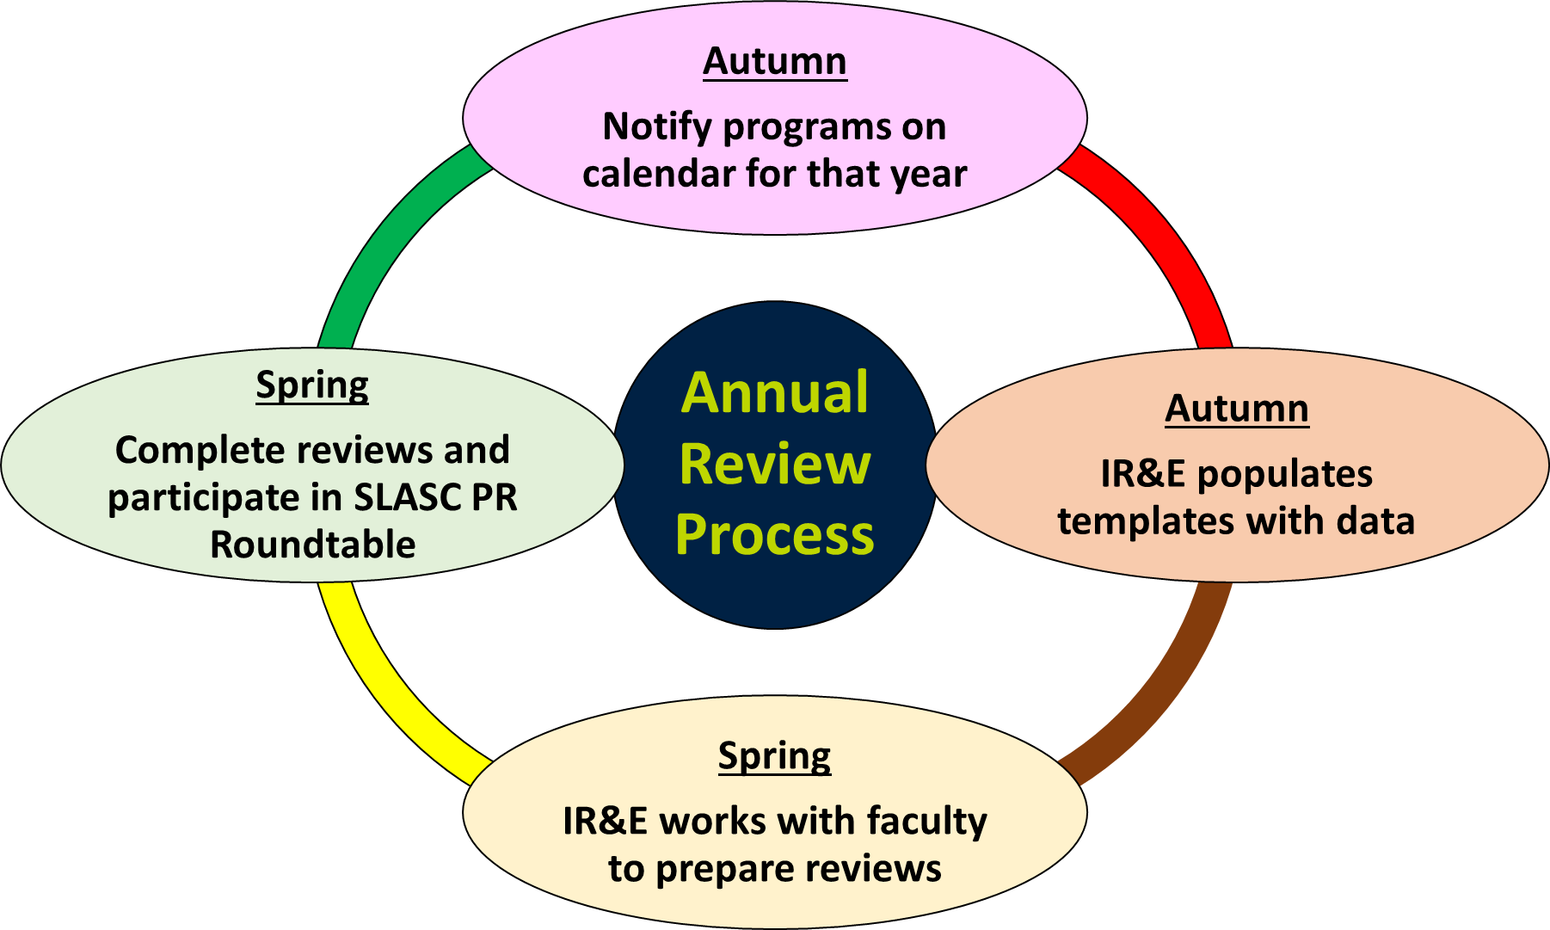

Questions may be sent to the Office of Institutional Research and Effectiveness at cotcire@mail.cotc.edu or to IR&E Analyst, Joe Argiro, at Argiro.1@mail.cotc.edu.

